**PRACTICAL-2**

**AIM**:

How your site performs, reveal why it’s slow and discover optimization opportunities with GTMetrix.

**SOFTWARE REQUIRED**:

Google Chrome and Microsoft Edge to open GTMetrix official website.

**BACKGROUND KNOWLEDGE REQUIRED**:

Basic knowledge and understanding of Software Engineering.

**THEORY**:

Introduction to GTMetrix:

* Developed by the parent company GT.net.
* It is probably one of the most well-known and used speed testing tools on the web today! In fact, the reason we are writing this is that we have a lot of Kinsta customers that are always asking us how to follow the advice they see on their GTmetrix reports. Compared to other developer tools, GTMetrix is pretty easy to use and the beginner can pick it up pretty quickly.

Features:

* Track performance with monitoring, graphs, and alerts.
* Get summary of key performance indicators.
* Test the page from multiple regions.
* Save report data.
* Connection Throttling.
* Cookie Sessions.
* HTTP Authentication.
* E-mail Digests.

Advantages:

* Compare the site’s performance.
* Review the site’s performance.
* Improve the site’s performance.
* We can analyze our page using both services i.e. PageSpeed and YSlow.
* Limitations:

Limited Speed tests.

* Image dimensions supplied through CSS cannot be detected leading to a wrong speed test report.

**IMPLEMENTATION/SCREENSHOTS:**

* Using Google Chrome:

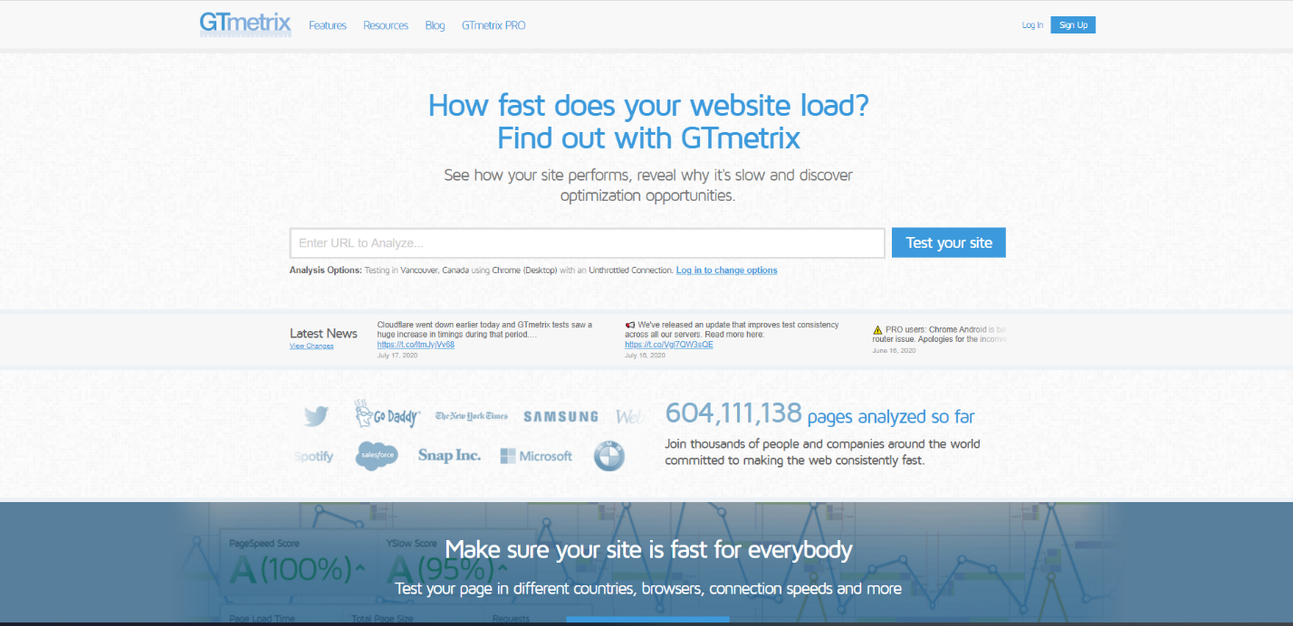

Home Page

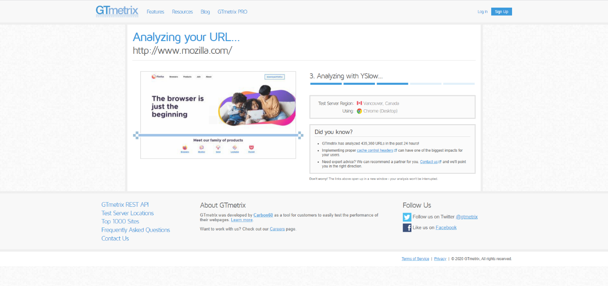

Analyzing with YSlow

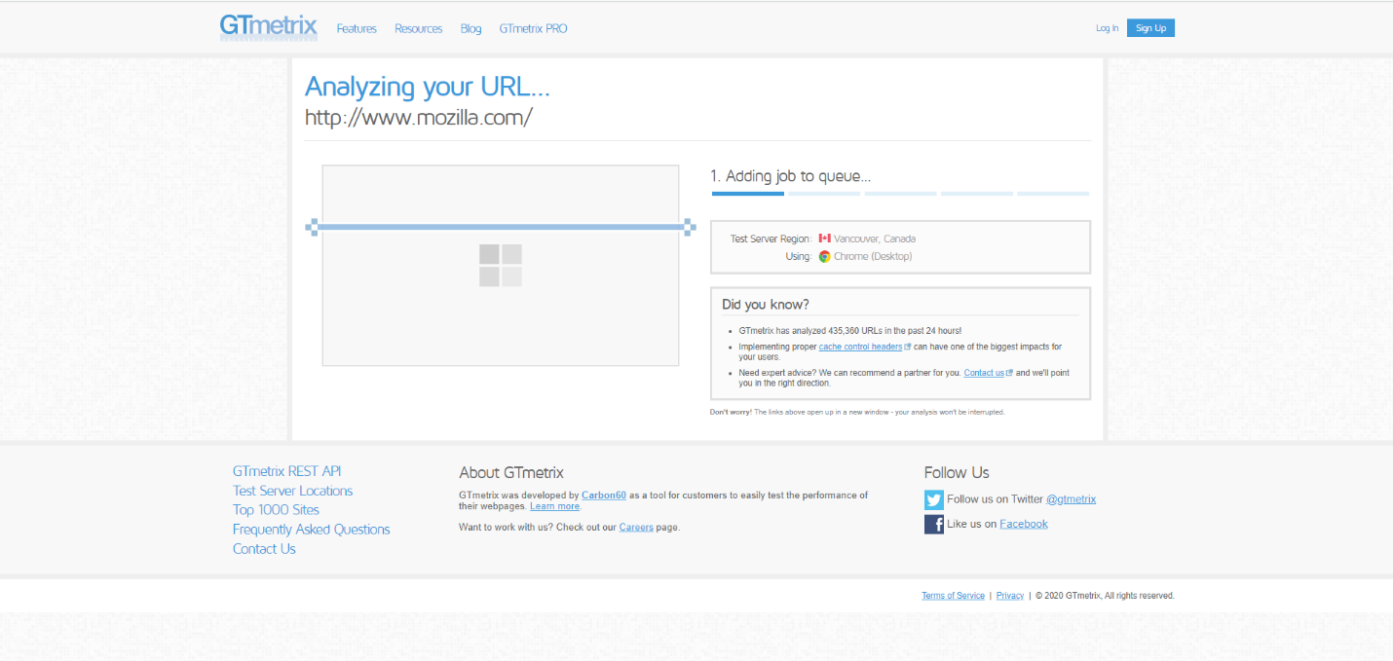

Adding job to queue

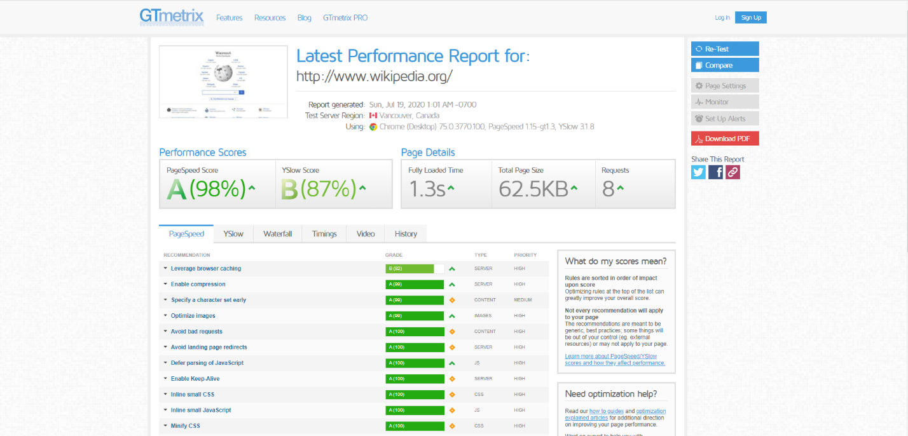

Report of URL

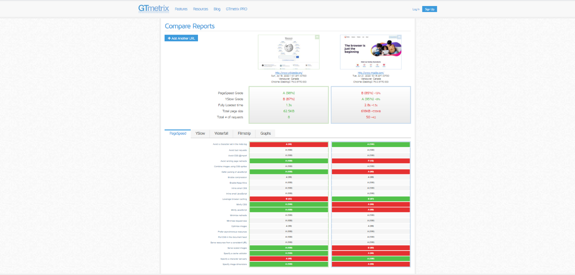

Comparing two URL

* Using Microsoft Edge:

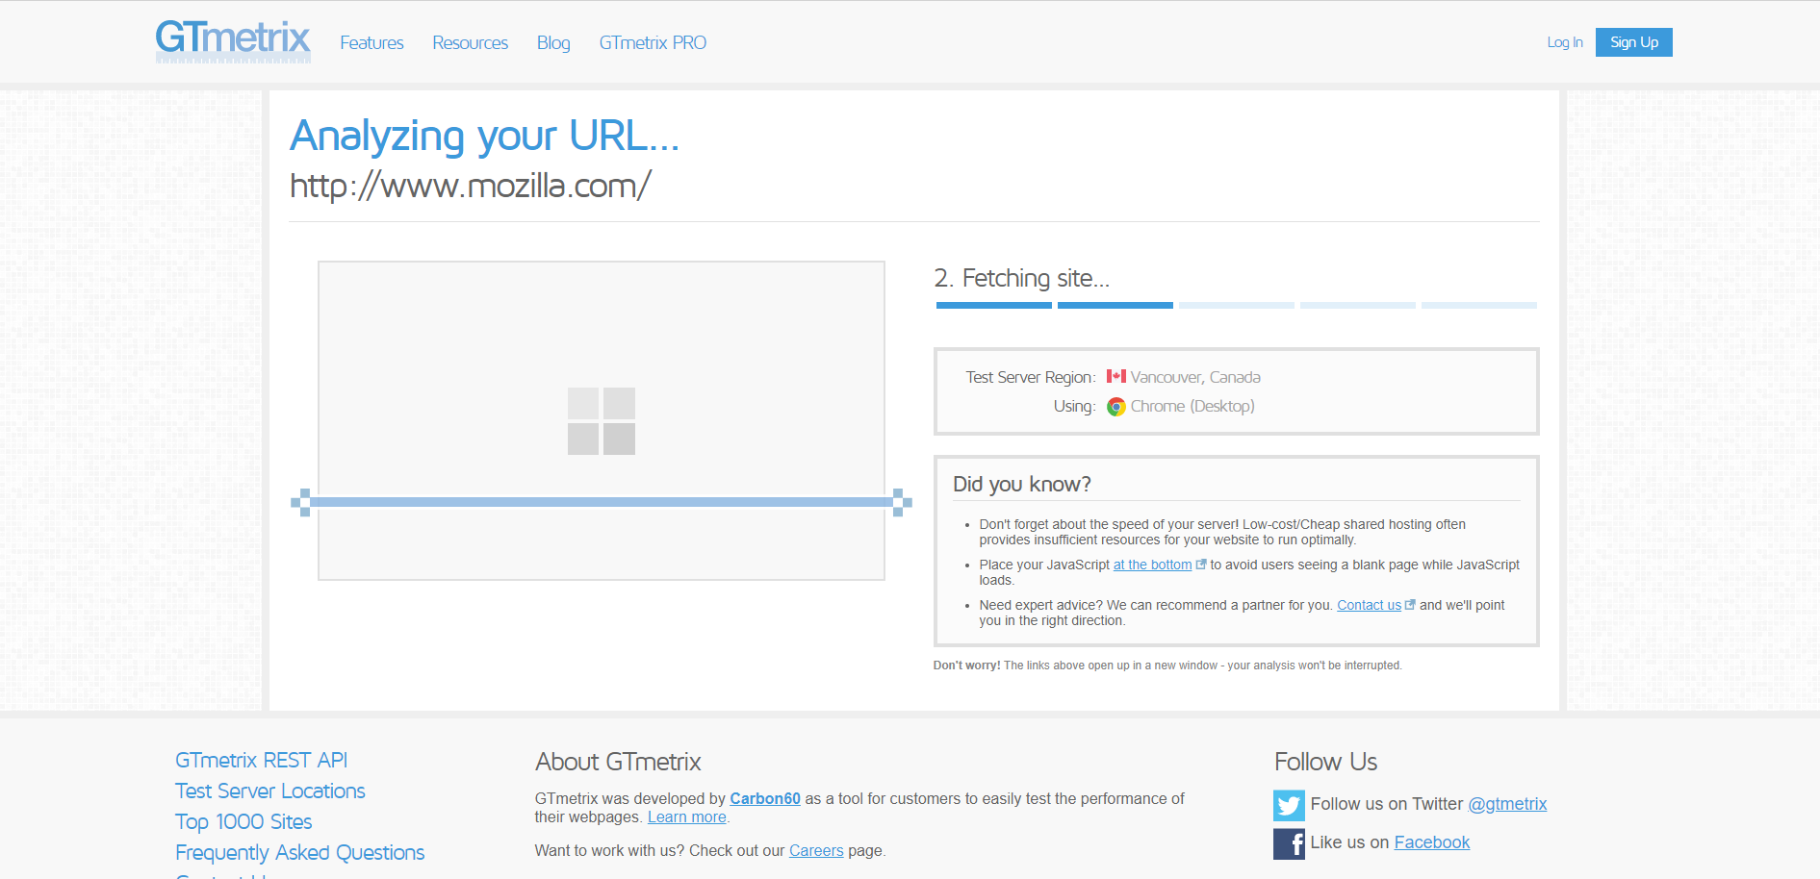

Fetching Site

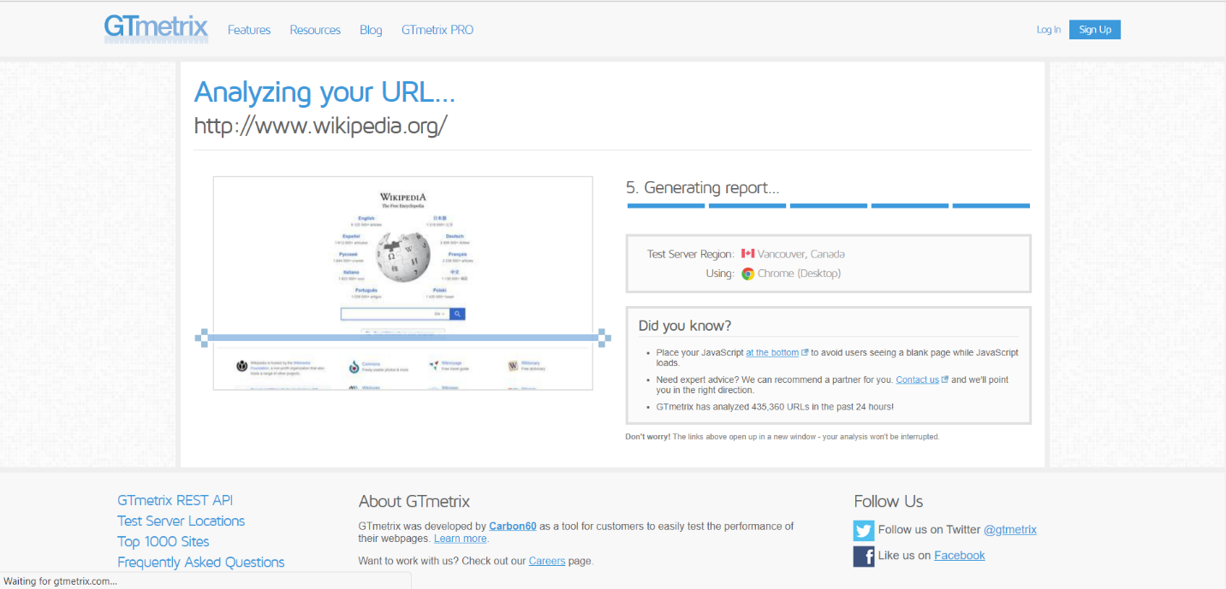

Generating Report

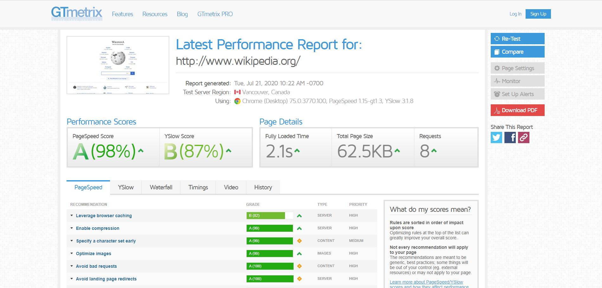

Report of URL

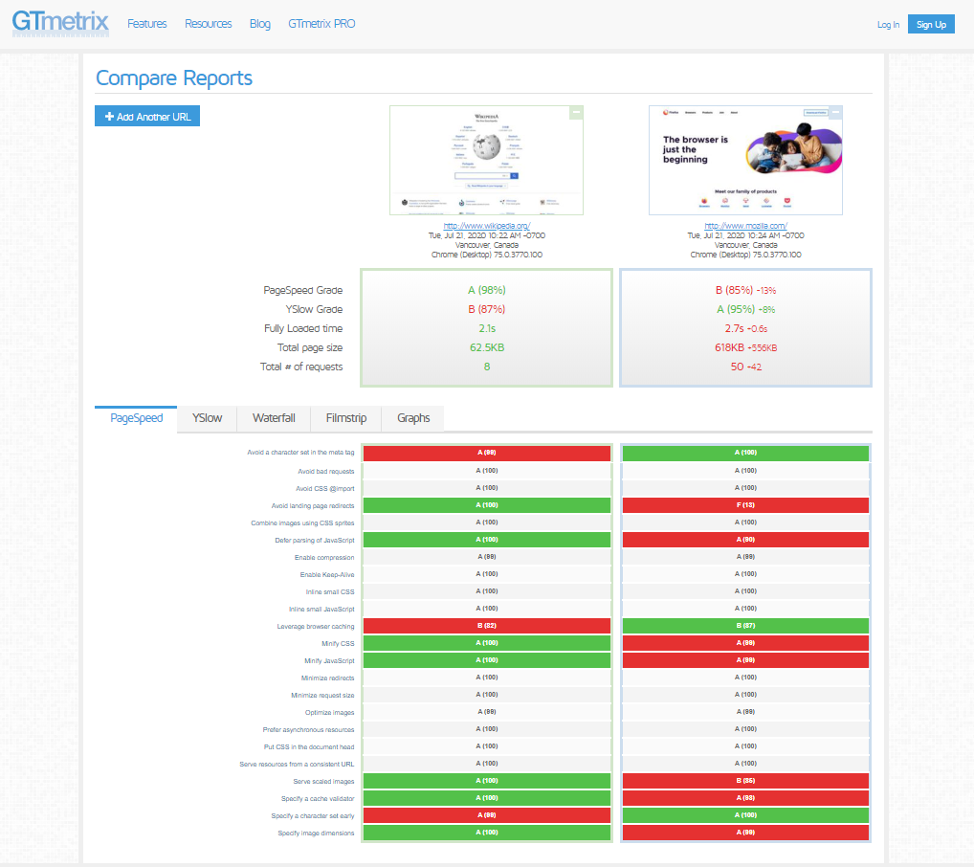

Comparing two URL

**CONCLUSION**:

From this practical, I understood to analyze how a website performance tool works as well as come across the website performance parameters on which the website performance is determined.

**REFERENCES**:

<https://gtmetrix.com/>